

**Project Report**submitted to: Sundas Aamir

**Ehtisham ul Hassan  
22I-1777  
CYBER – A**

Contents

Introduction: 3

Subnets calculation 3

Topology: 4

Configuration: 4

RIP 4

OSPF 4

EIGRP 4

Redistribution: 5

DHCP 5

Email server: 5

Web server: 6

ACLs: 6

NAT: 7

# **Introduction:**

The project is implemented using all the concepts of computer networks the networks are made and configured to communicate to the other networks as per the requirements of the project

# **Subnets calculation**

vlsm is calculated by a tool and also implemented on the router networks  
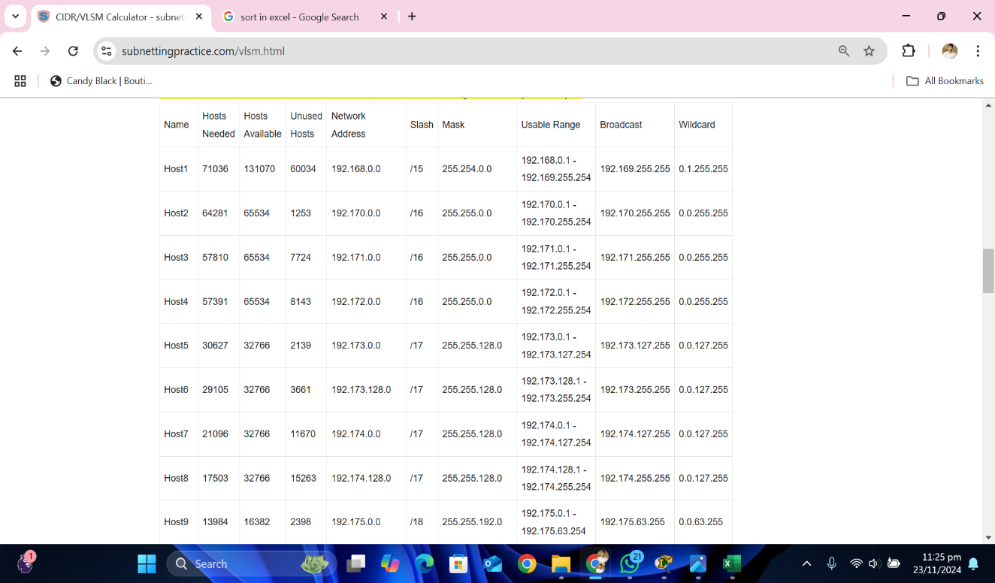

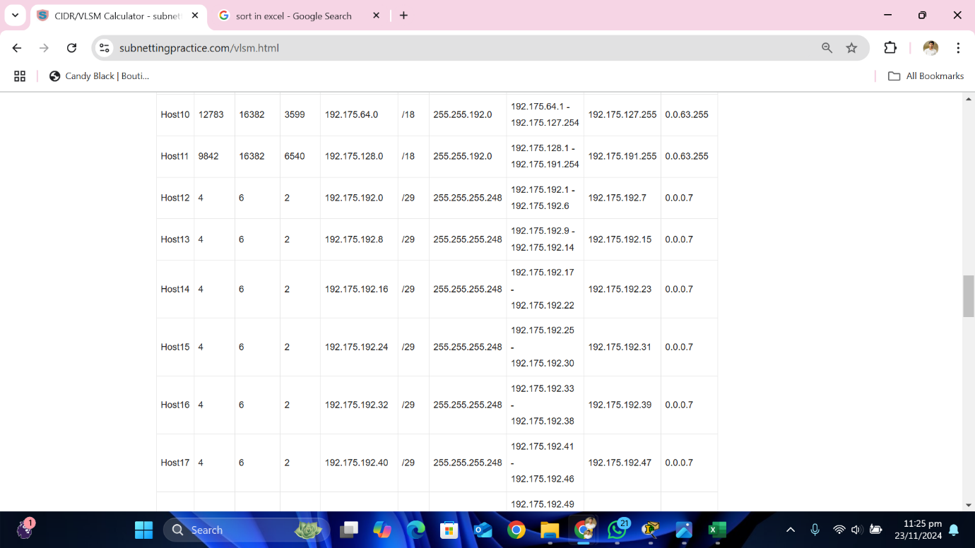

# Topology:

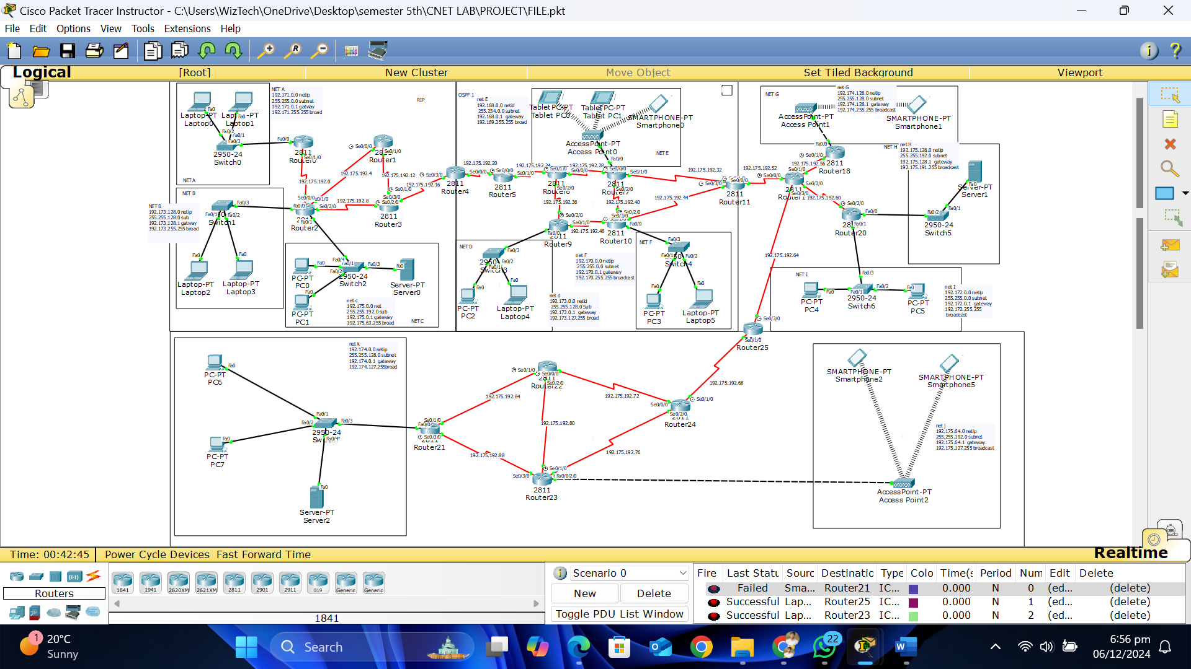

# Configuration:

# **RIP**

RIP version 2 is used to enter all of the networks on the routers specifically and it works perfectly with in he RIP zone before redistribution

# **OSPF**

OSPF 10 is configured in the central area and it is working properly within the network D, E, F.

# **EIGRP**

EIGRP is configured just like the OSPF but it uses the wild card mask instead of  
subnet.  
  
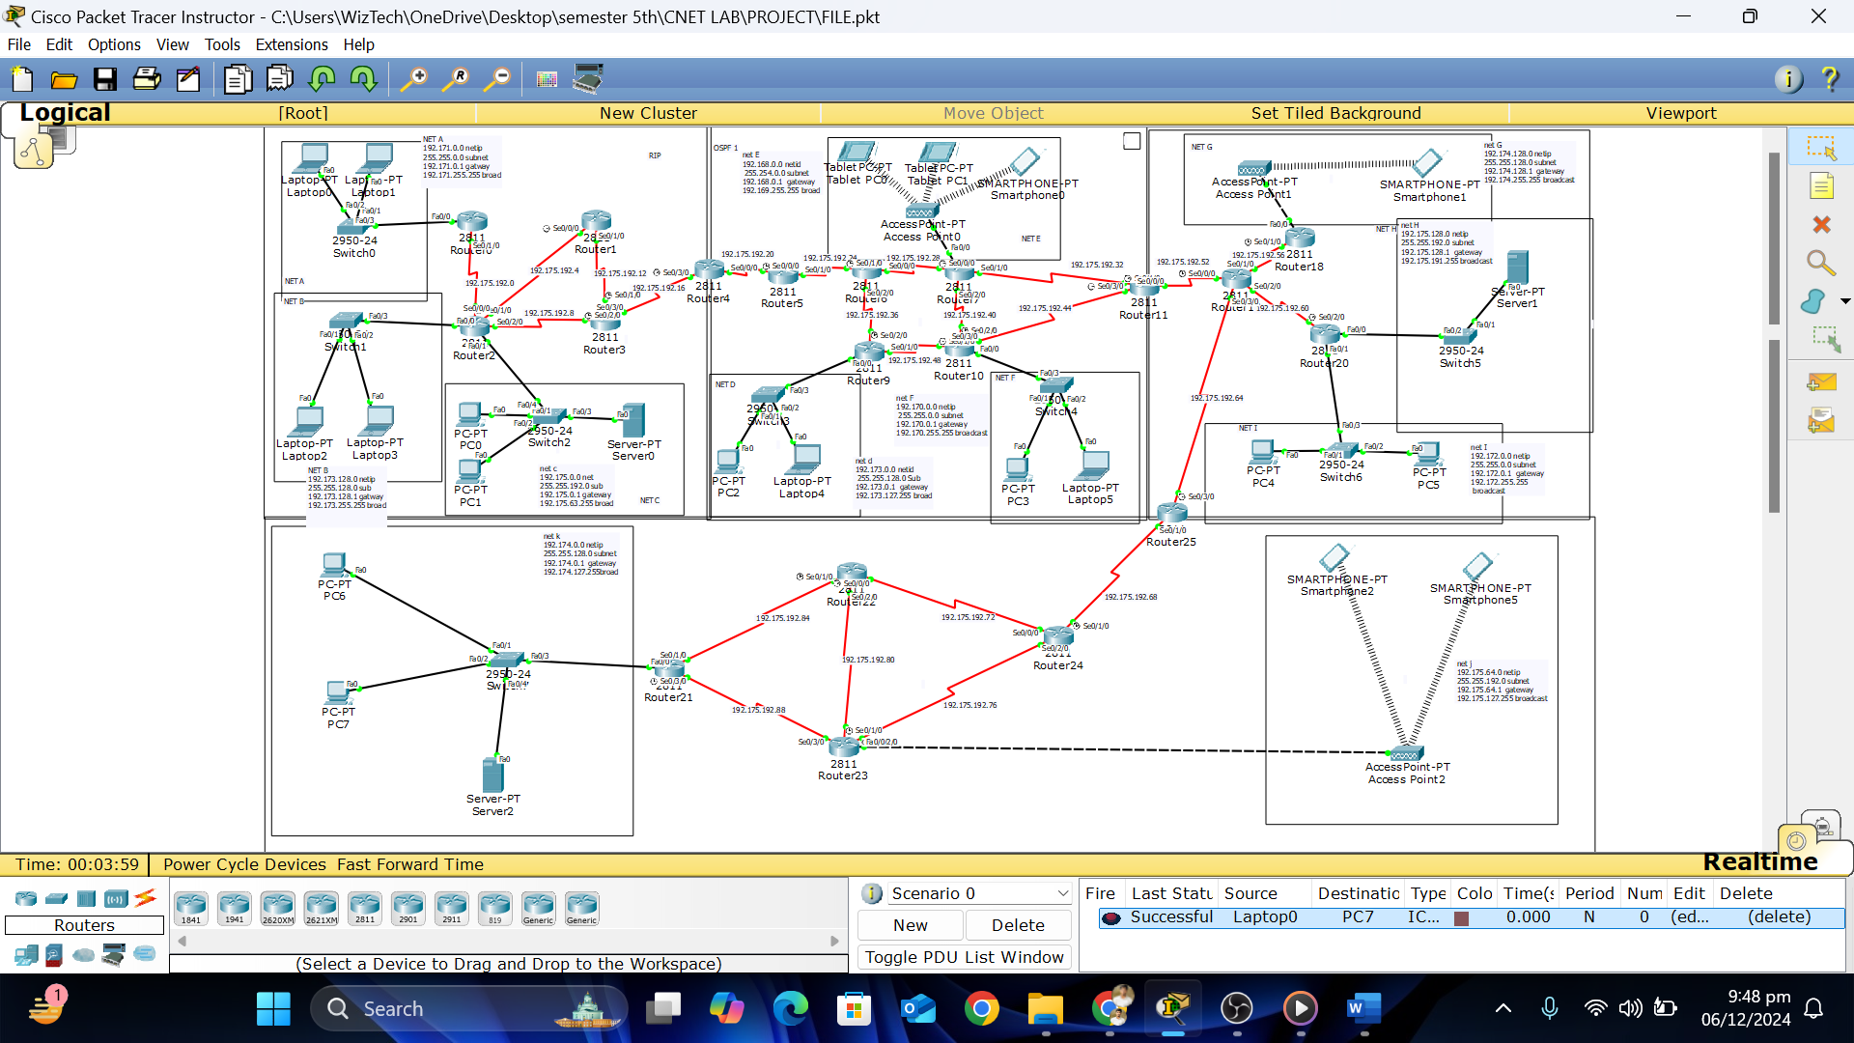

# Redistribution:

Redistribution is done on the mutual routers of different algorithms

# DHCP

DHCP is configured in the network k block that helps to assign the ip addresses to all of the host across the different networks.  
  
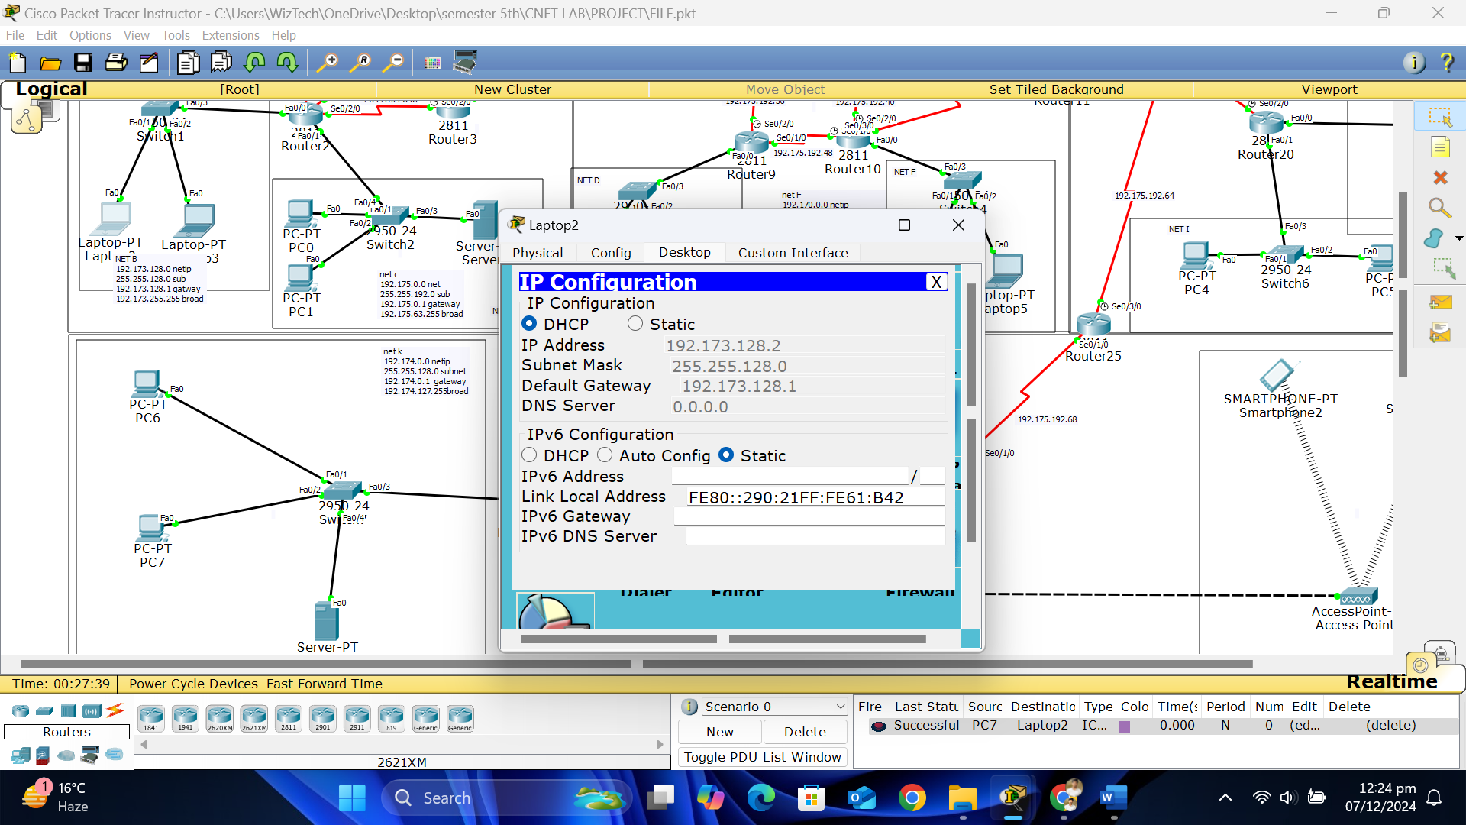

# **Email server:**

Email server is setup in the first block and it delivers best email service to all of the clients of different networks  
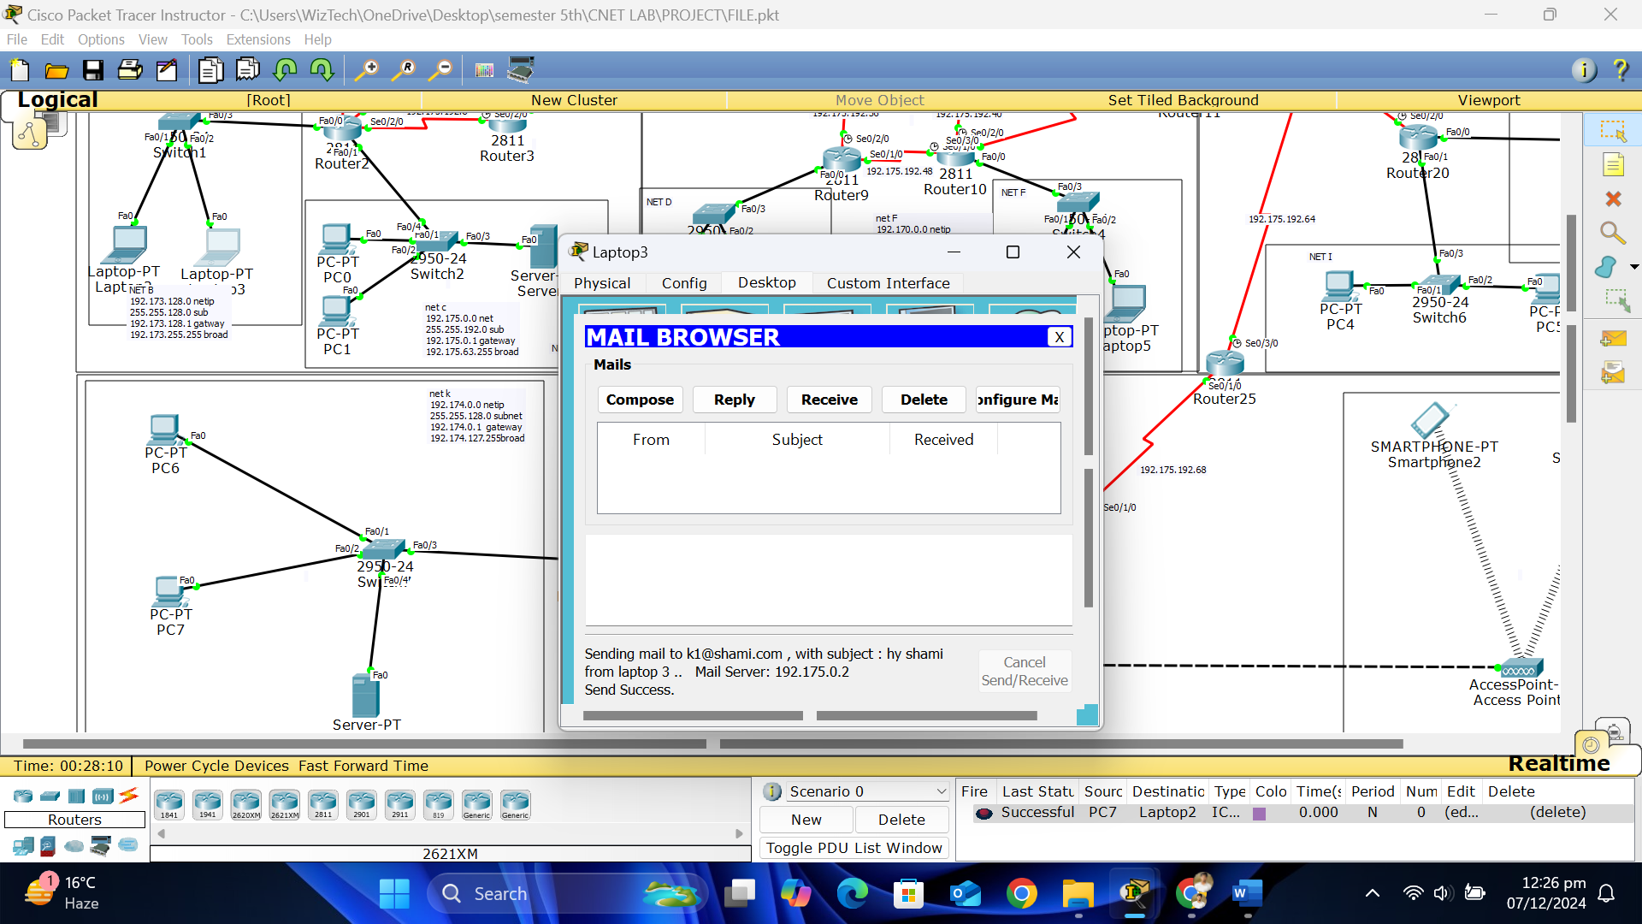  
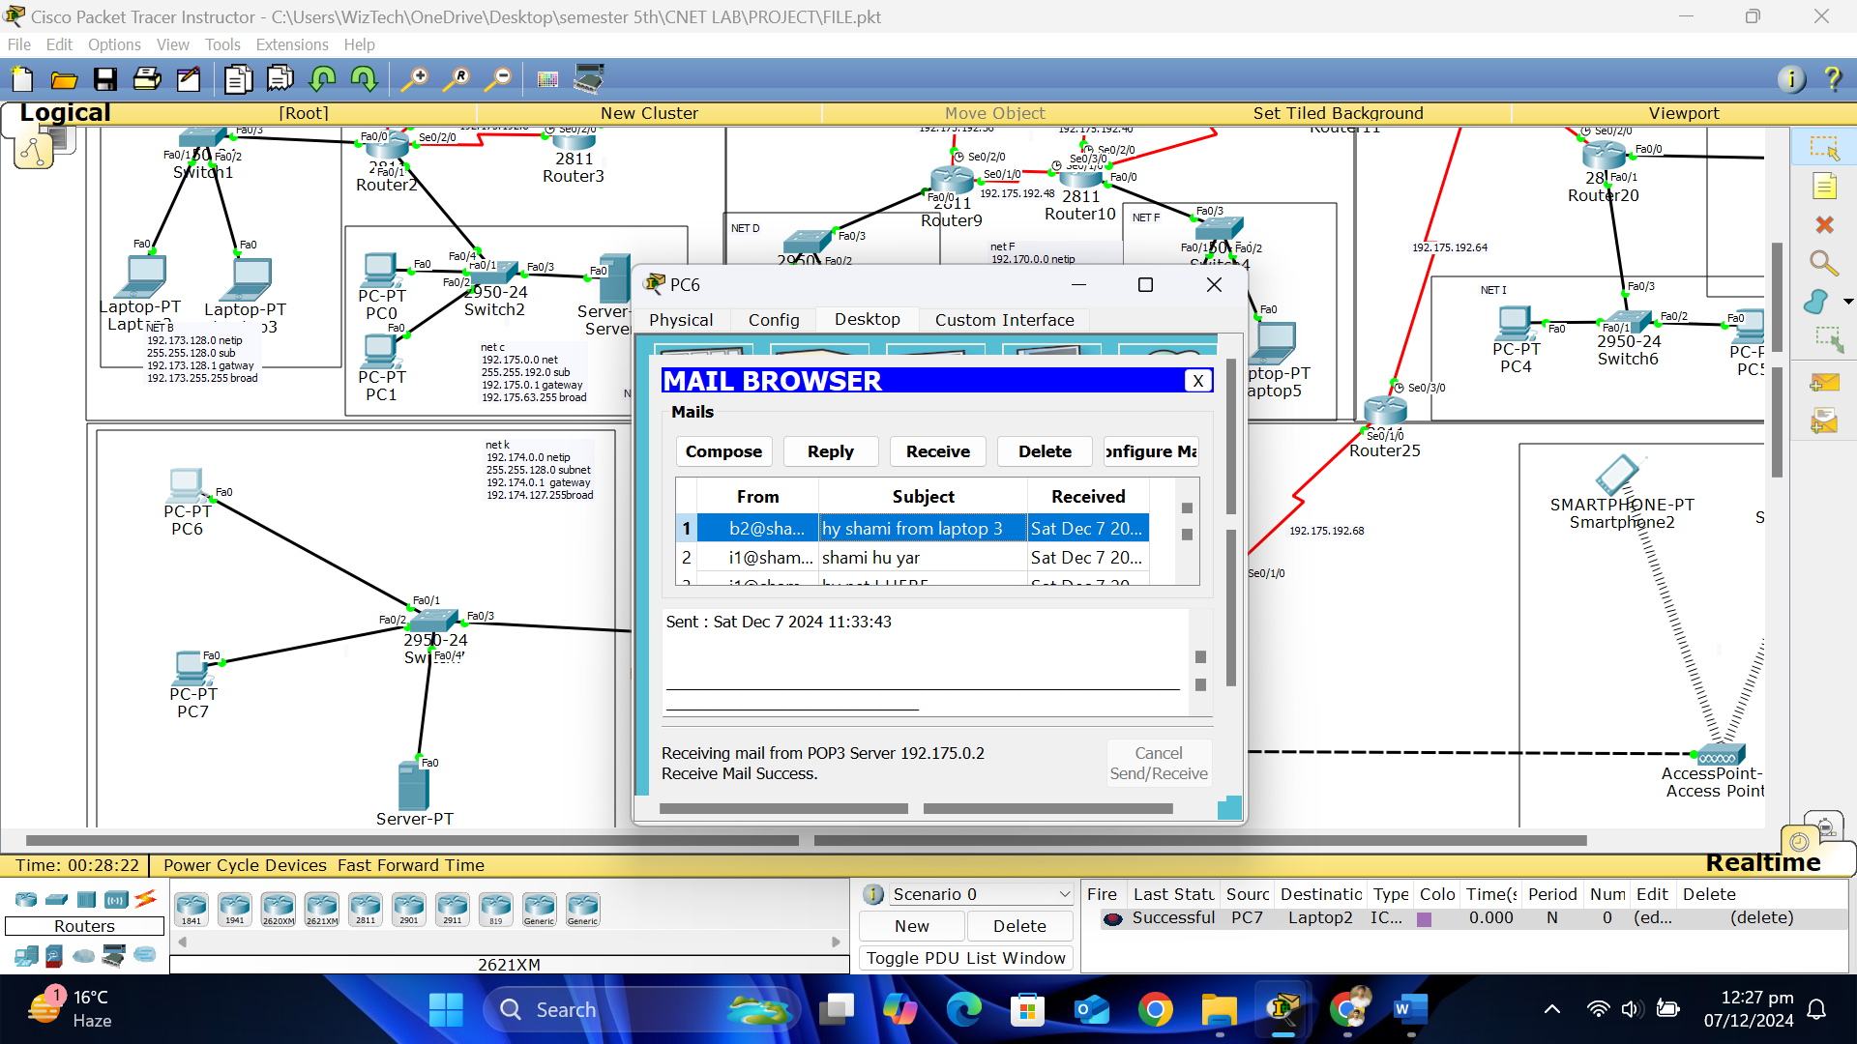

# Web server:

web server is deployed in the network H and it will be restricted to allowed computer of multiple networks according to requirements it will be done by implementing ACLS.

# ACLs:

Starting IPs of required networks are blocked through ACLs on the adjacent router of the server

# 

# NAT:

Nat has been configured on the required routers and it is showing malfunctional behaviour to some extent

